* **My Q&& AAS**

1. **- How do you identify the test cases which are suitable for automation:**

**1.Functional test case case are we are able to automate.**

**2.Non-functional test case are we are not able to automate.**

**3.Which task are u want daily execute those functionality are we are able to automate.**

**4.OTP ,Capthaca functionality are not able automate.**

1. **- What all things can you automate?**

**1.Functional test cases are we are able to automate by using selenium with java.**

1. **- When is Automation testing useful?**

**1.for doing repeated functionalities. ex: Registration form filling.**

**2.When u are performing Re-Testing, Regression Testing at the time Automation Testing is useful.**

1. **- How to decide the tool that one should use for Automation testing in their projects?**

**1.depends upon the project budget.**

**2.prefer open source tool.**

**3.We need to take the project requirement.**

**If the project have only web application testing,Mobile application**

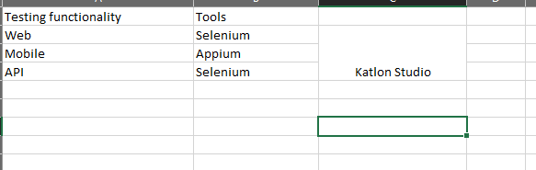

1. **- Currently I do not have any automation in place in my project, but now I want to implement automation, what would be my steps?**

**1.u need identify the teases for automation**

**2.identify the repeated test functionalities.**

**3.first u need Select the one open source tool. Why because of the reason it is open source and company no need to pay the money.**

**U need to do one POC(Proof of the concet).after completion of that u need show company .if they are approving u have acces doing entire automation.**

1. **- Once you identify the tool what would be your next steps?**

**1.Need to take the requirements.**

**2.need to identify & which teases are able to automate.**

**3.take all the inputs from manual team.**

1. **- Any kind of test which you think should not be automated?**
2. **OTP ,Capthaca functionality are not able automate.**
3. **Non-Functional testing we are not able to perform.**
4. **- Do you think that testing can be done only at the UI level?**
5. **By using automation We can do only UI level functionalities**

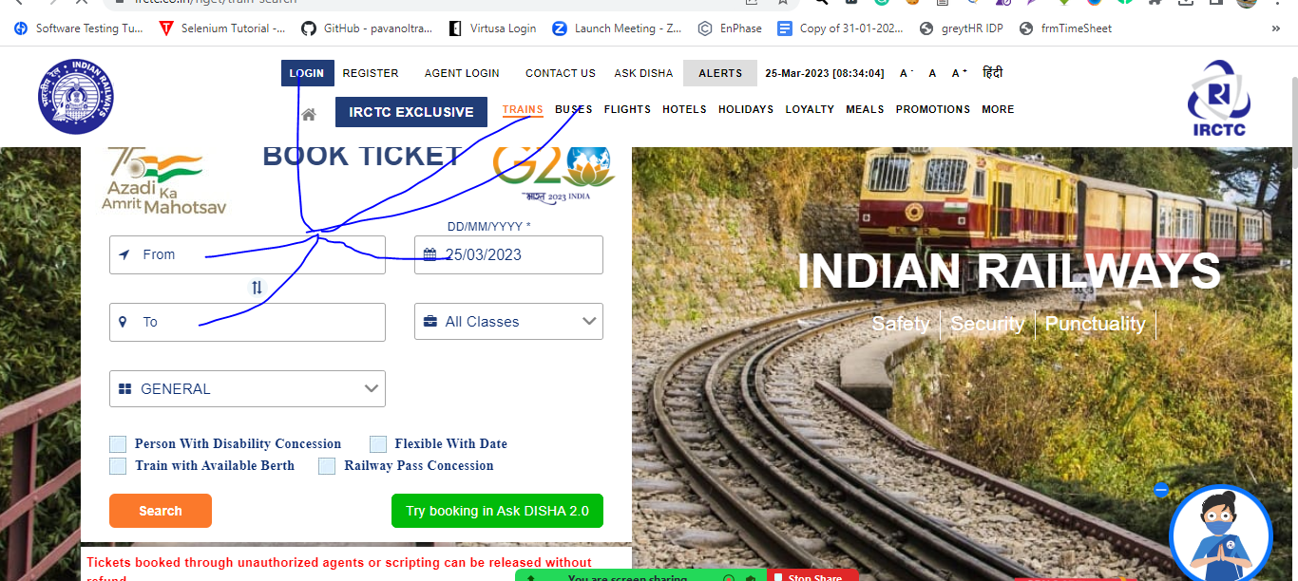

1. **- When do you prefer Manual testing over Automation testing?**

**1.To overcome the speed of the execution.**

1. **- Is Automation testing in agile Methodology useful or not?**

**1.It is useful why because of the reason we can develop the script with in sprint time period.**

1. **- Can we do Automation testing without a framework? If yes, then why do we need a framework?**

**1.We can do without frame work also but we are not following any frame work standards. if u are following any framework we can develop the automation script with standards.**

**13 - How will you automate basic “login” functionality test cases for an application?**

**1.We need to write Positive cases and negative cases also.**

**14- Is Automation testing a Black box testing or White-box testing?**

**Automation testing is comes under Black box testing**

**15 - What factors determine the effectiveness of Automation testing?**

**16 - Which test cases can be automated?**

**1.Repative functionalities,Functional Test case we can able to automate.**

**17 - What are the phases in Automation testing Life Cycle?**

**1.Need to identifi the tecases**

**2.Need to identify the tool.**

**3.Need to identify the coding langauage.**

**4.Need to identify the framework.**

**5.Need to identify pre-conditions.**

**6.Maintain the scripts.**

**18 - What is an Automated test script?**

**1.it is group of the programs.**

**19 - On what basis you can map the success of automation testing?**

**1.Saving execution time.**

**2.reduce the resource.**

**3.Maintance also less.**

**20 - What are the five common solutions for software developments problems?**

**1.Requirments**

**2.Resource.**

**3.Environments**

**21 - Why does software have bugs?**

**1.during development if developers are not developed as expected the time tester are identify the bugs.**

**22 - How can new Software QA processes be introduced in an existing organization?**

**1.Need prepare proper documentation of the new Software.**

**2.Need to give the proper demo.**

**3.Need give the training session.**

**4.Conduc the practical session etc.**

**23 - What kinds of testing should be considered in manual testing?**

**1.We can conduct both Functional and Non-Functional Testing also.**

**26 - What makes a good test engineer?**

**1.For identify the requirments.**

**2.Conduct the execution in testing standards,**

**3.Follow the all Testing techqnies for Testing**

**4.Identify the all bugs**

**5.Conduct the testting untill client satisfaction and client requirment.**

**27 - What's the role of documentation in QA?**

**1.U need to Write tescase and Tetscenarios.**

**2.Need to prepare the RTM**

**28 - What if the software is so buggy it can't really be tested at all?**

**1.Need to take the all bugs.**

**2.Need to take the approval from manager for testing.**

**3.need to conduct the testing again.**

**29 - How can it be known when to stop testing?**

**1.If all the bugs are closed.if it error less . we can stop testing.**

**30 - What if there isn't enough time for thorough testing?**

**1.perform Monkey testing and Explortary testing**

**Thanks Slim.**